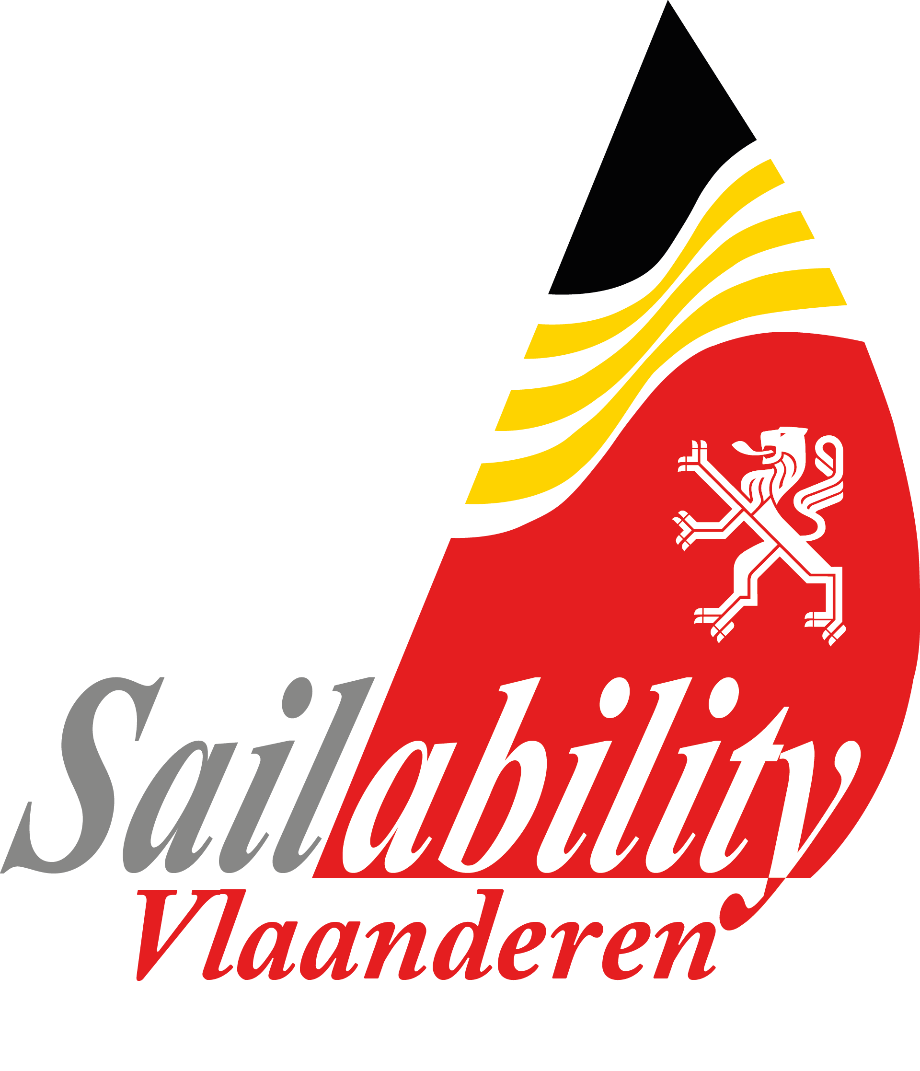

Sailability Vlaanderen

Hansa 303 (w / b) and Liberty CLASS

Flanders Sailability Cup

to be sailed on the Zilvermeerhaven „Port Aventura“ (Mol, Belgium) from

23rd – 25th May 2015

Entry Form

Please complete this entry form.
Marked fields (*) are required information, completing all relevant information is recommended.

Class (*): 303 Wide (Single) / 303 b / Liberty - Servo

Country Sail Letters : ..
Sail number (*): ..
Yacht Club : ..

Name (last & first name) (*): ..
Date of Birth :(*) .. M / F (*)
Address (street & N°) (*): ..
Postal code (*): ..
Town (*): ..
Country (*): ..
Phone (home) :
Phone (mobile) : ..
Email (*): ..

Do you have a disability : Y / N
If so, do you have any special needs ? ...
(- this information is used for your safety & comfort and will be kept confidential)

....

E.T.A. -date / time (*): ..

Comments : ..

Please inform us if you have any medical needs.
(this information is used for your safety and will be kept confidential)
Catering : Optional indication
We have the possiblity to serve for you Breakfast, Lunch and/or Dinner in the Championship Tent.
Indicate in the table below, wich time you want a meal and for how many people. So we can plan staff & stock

Breakfast : Lunch pack : Dinner :

Saturday .. .. BBQ (20 € pp incl. drinks)
Sunday .. .. ..
Monday .. .. ..

•• DECLARATION : By returning this completed entry form, the applicant agrees to be bound by the Racing Rules of Sailing of the I.S.A.F., by the Notice of Race, the Class Rules and the Sailing Instructions. All those taking part in the event do so at their own risk and responsibility. The Organising Authority and all parties involved with the organisation of the event disclaim any and every responsibility whatsoever for loss, damage, injury or inconvenience that might occur to persons and goods both ashore and on the water as a consequence of participation in the races covered by the Notice of Race. ••
•• PRIVACY : conform Belgian Law the information submitted will be used exclusively for internal and administrative goals of the club and the federations and will not be disclosed to third parties. Upon simple request the information can be verified at the club. The applicant accepts, in accordance with Belgian Law governing publicity by electronic correspondence, to receive emails concerning the events.••

